Stand: 06.04.2014 12:12 Uhr

A refuge for threatened human rights activists
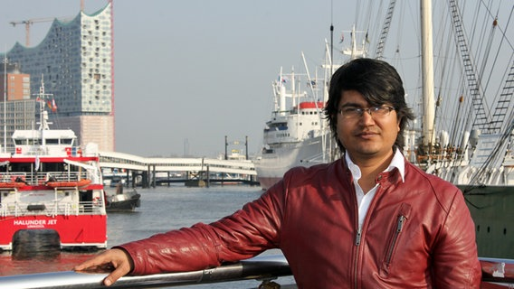
In his home country Bangladesh, blogger Asif Mohiuddin is considered an "enemy of the Islam" and thus exposed to threats – for one year, he will be living in exile and staying with the Foundation for Politically Persecuted People in Hamburg.

First, the blows to his head made him stagger. A dull, agonizing pain. Then they stabbed him – 53 times. When his attackers eventually let go of him, he lay in his office steeped in blood and critically injured.

Living in constant fear
Mohiuddin is a human rights activist. In his home country Bangladesh, the 30 year-old blogger is fighting for the rights of women and the right to education, while also promoting a critical attitude towards the fundamentalist Islam. His attackers were Islamic extremists. Mohiuddin will always be treated with hostility because of his statements but following the knife attack in January 2013, his life altered. Fear and hiding are now his constant companions.

"The fellowship is the greatest gift"
For now, however, he can relax: The Hamburg Foundation for Politically Persecuted People has invited the blogger to stay in Hamburg for one year. “This is the greatest gift and I could hardly believe it when I received the message,” Mohiuddin says. The young man has been in Hamburg for one week and now has the chance to unwind and regain his strength. This is also the main goal of the non-governmental organization. Each year since 1986, the foundation has awarded five to eight human rights activists with a one-year fellowship. Initially, Klaus von Dohnanyi, First Mayor of Hamburg at the time, brought this idea to life. In 28 years, around 140 persecuted people have found refuge at the river Elbe: amongst them women’s rights activists from Iran, opposition leaders from Nigeria, Kurdish attorneys and Russian journalists.

The foundation’s guests are fully provided for
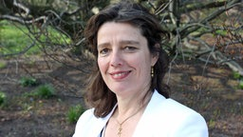
For 22 years, Martina Bäurle has been managing the Foundation for Politically Persecuted People with great skill and devotion.
The Foundation for Politically Persecuted People not only pays for their guests’ plane tickets to Germany, they also provide a year’s rent for an apartment, a monthly allowance, phone expenses, health insurance and language courses. Depending on how many family members a guest brings along, a fellowship amounts to 25,000 to 33,000 Euro. The foundation itself is funded by the Hamburg Senate as well as private donations. In return, the foundation’s guests offer their experience: They talk about their home countries and their ideas at panel discussions and in schools, they publish their reports and act as multipliers. At the end of their stay, the foundation’s guests go back with a broadened network. For this reason, the foundation organizes events with other human rights activists, encouraging exchange.

"Giving up is not an option"
If circumstances allow it, most activists go back to their home country after their one-year stay. Blogger Mohiuddin also intends to do so: "Giving up is not an option for me. I will go back to Bangladesh and keep on fighting for the freedom of speech."

Admiration for the activists’ courage
"I admire all of these people. It’s tremendously courageous to dedicate their lives to such great ideas like democracy and freedom and not let anyone intimidate them. They have to put up with so much," says Martina Bäurle. For 22 years, she has been managing the foundation and is executive manager, event and PR manager, psychologist and interior designer all at once.

Getting settled in Hamburg is often difficult
"Extending a warm welcome" – this is her philosophy. To put it into practice, she likes to meet her guests at the airport with flowers in hand, having filled the fridge in the guest’s apartment with their home country’s traditional foods prior to their arrival. She wants to build trust and create a friendly atmosphere because many guests experience difficulties when trying to settle in. The constant physical and psychological sense of danger they have come to live with in their home countries is still too present.
Mohiuddin, the blogger from Bangladesh, also finds it hard to leave the house without his mask or casually sit in a café in his new neighborhood, the Schanze. Loneliness, however, is the biggest challenge most guests face in the beginning. Despite Martina Bäurle’s best efforts to indulge the foundation’s guests in group outings and meets and greets with people from Hamburg, the first three months are the hardest. During his one-year stay in Hamburg, Mohiuddin wants to learn about French poets and German philosophers: Nietzsche, Kant, Marx. This is also an unknown kind of freedom to him – he cannot remember the last time he was able to enjoy reading a book in peace and quiet.

