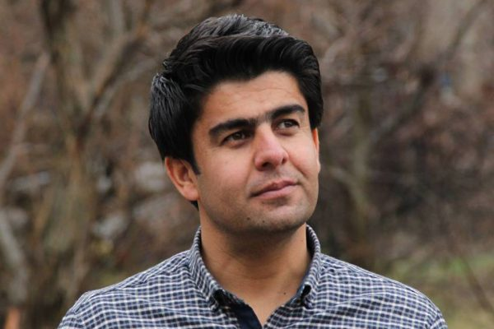

KAMAL CHOMANI

Freelance Journalist and Political Analyst

Kamal Chomani works as freelance journalist and political analyst writing on the political affairs of the Kurdistan Region and covering Kurdish politics in Iraq, Iran, Syria and Turkey for leading impartial Kurdish media outlets.
His reporting has exposed him to smear campaigns, reprisals and even death threats in his home country and is therefore currently in exile in Europe. From 2009-2011, Chomani was correspondent for „Reporters Without Borders“ in the Turkish Kurdish regions. Since 2010 he writes as a columnist for „The Kurdistan Tribune“ and blogs for „The Times of Israel“.

Kurzvorträge und Gesprächsrunde

Pressefreiheit in Gefahr! Journalismus in der Türkei und im Irak

https://medientage.de/referenten/
Münchner Medientage Gespräch am 24.10.2018 von 17:10-18:00 Uhr, Raum 62a

