ON THE CRIME OF BEING A HUMAN RIGHTS DEFENDER
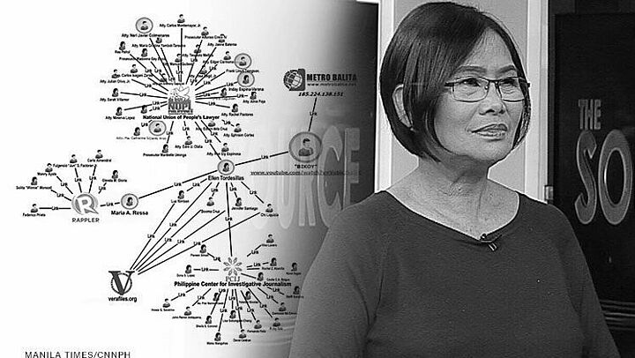

21. October 2020
19:00 - 21:30 Uhr

Helmut Schmidt Auditorium

In cooperation with the Hamburg Foundation for Politically Persecuted People and the Amnesty International Chapter of Bucerius Law School
Ellen Tordesillas, Journalist, Philippines
Charlotte Gehl and Timon Weiler, class of 2019 (moderation)
There are few other countries where so many journalists are murdered as in the Philippines. Ellen Tordesillas is one of those activists who made it their mission to fight the oppressive regime and shameless enrichment of the dictatorial couple Ferdinand and Imelda Marcos. Although facing criminal charges and receiving death threats, Ellen co-founded a platform in order to unmask the political corruption and abuse. She believes that transparent media coverage is fundamental to a free and enriching debating culture. The Hamburg foundation for politically persecuted people has given her the opportunity to stay in Germany for a year and pursue her fight in a safe harbor.
The award-winning journalist will share her life story and experience of being a human rights activist with us. The Amnesty International HSG invites you to join a lively discussion about the situation in the Philippines and the meaning of the freedom of press.
Registration needed
https://www.law-school.de/international/event/on-the-crime-of-being

