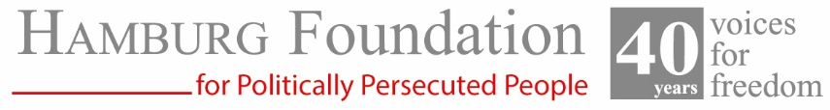

Press release
Hamburg, March 12, 2026
New foundation guest: Omar Radi
Journalist from Morocco

The Hamburg Foundation for Politically Persecuted Persons has accepted Moroccan journalist Omar Radi as a guest of the foundation. The foundation advocates worldwide for people who courageously raise their voices against injustice and offers them protection and peace in Hamburg for a temporary period of time.

For more than a decade and a half, the investigative reporter has resisted various smear and defamation campaigns. Since 2008, Omar Radi has been reporting on secret agreements between political powers, large corporations, and the role of the state in the land grabbing of marginalized populations and communities, which has led to the forced resettlement of farmers and villages.

For example, a group of wealthy entrepreneurs known as the “Sand Mafia” pressured villagers to sell their sand deposits under their hamlet at extremely low prices. Such unfair deals usually go unnoticed. But the residents witnessed the resale of “their” sand at 600 times the price they were paid.

When Omar Radi investigated the links between real estate development and land expropriation by the state, it was only a matter of time before the authorities targeted him and began a sustained campaign of intimidation and harassment.

In June 2020, the Moroccan authorities began investigating Omar Radi as a result of his research. From this point on, he was subjected to even more repressive surveillance, his computer and cell phone were infected with the Israeli spyware Pegasus (source: Amnesty International 2020), he was attacked with batons, tried and imprisoned when he criticized the harsh sentences handed down to a group of land activists, and his car was destroyed: It was the beginning of a massive intimidation campaign to prevent him from doing his work.

On July 29, 2020, at the behest of the head of counterintelligence, he was charged in a flimsy trial with espionage, undermining the Moroccan state, and two counts of rape and sexual assault, and sentenced to six years in solitary confinement (Amnesty International 2024). He was imprisoned and placed in solitary confinement on the same day. Amnesty International called it: "Fake sex crimes as a weapon against unwelcome journalists.

On July 29, 2024, the Moroccan authorities released journalist Omar Radi along with other colleagues, a human rights defender, and activists after they were pardoned by the king.

